 Bishops Hill
Wine Club Membership
___ 1 Bottle Club Members - $20
Receive 1 bottle a month of any wine of your choice at $25 and less. Premium Cabernet will require 2 months of credits.

___ 2 Bottles Club Members - $40
Receive 2 bottles a month of any wine of your choice at $25 and less or 1 bottle of the Premium Cabernet.

Your credit/debit card will be charged immediately when you register for a membership and then charged on that day every month afterward. At this time we only have pickup at the winery during business hours which are Thursday 4 p.m. – 8 p.m., Friday 3 p.m. – 8 p.m., Saturday 12 p.m. – 8 p.m. and Sunday 12 p.m. – 4 p.m. On pickup at the winery you will receive as many wines as you have paid to point of pickup. For example if you have paid 5 months prior to pick up, you will receive 5 bottles of 1 bottle club membership or 10 bottles of 2 bottle club membership.
WINE CLUB BENEFITS
The below bottle discounts are ONLINE ONLY and all purchases will be pickup only at the winery during business hours. All bottle purchases at the winery are 10% off regardless of quantity.
- 10% off wine purchases 1-5 bottles.
- 15% off wine purchases 6-11 bottles.
- 20% off wine purchases 12 bottles and over.
Other wine club benefits:
- 10% off all non-wine bottle purchases except tastings (see next bullet), events bookings, gift cards and wine and yoga.
- 10% off Wine Class 101 for you and your guests. Use coupon code CLASS at checkout.
- 30% off all wine tastings for you and your guests. Use coupon code TASTE at checkout.
- Special Wine Club Only events and pricing.
- $25 Gift Card on your birthday

If you choose not to become a wine club member you will still get a 10% discount on bottle purchases of 12 and over when you go to the shop.

To register go to bishopshill.com and go to Wine Club dropdown and select Member Login. The following will come up.
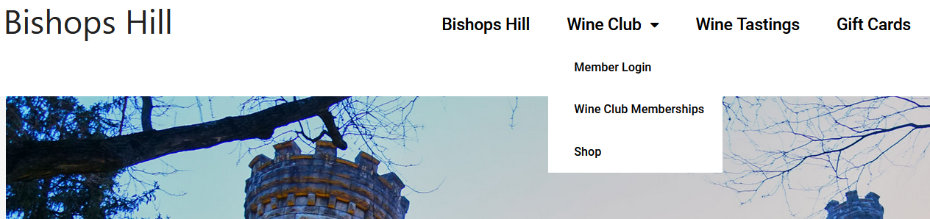

If you are a new member put in your email and password in the Register (as shown below). You will hit Register then logout and log back into Login on the left. If you are an existing member just go to Login. When logging in you can use only username which is dropping everything after and including the @ (i.e. email address is johnmarks2133@gmail.com your username would be johnmarks2133) .
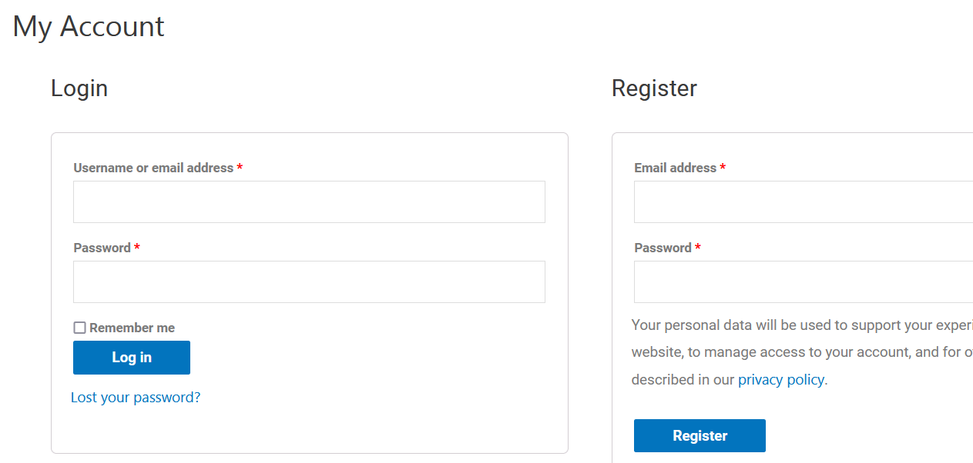
After you login you will see the screen below. Click on the address option to the left highlighted in yellow and Click the Add under the Billing address and fill in all your billing information. This will allow you to not have to fill in this information when you purchase in the shop since it will be prefilled saving you time when purchasing wine.
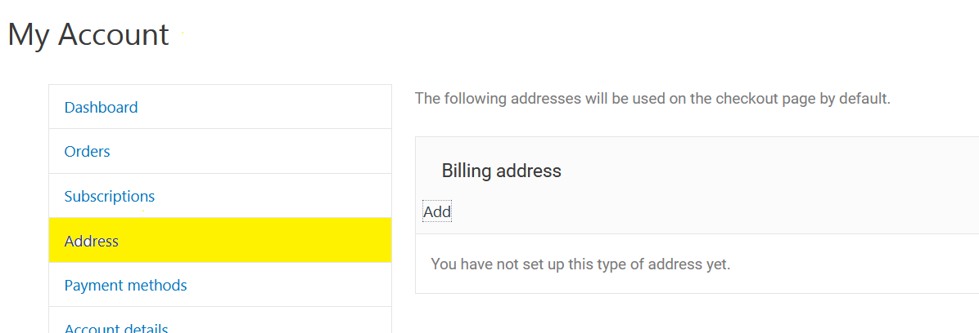

Go back to the Wine Club drop down at top of page and select Wine Club Memberships. You will see the page below. Select which membership you would like. You will only get Wine Club benefits after registering for one of the memberships below.
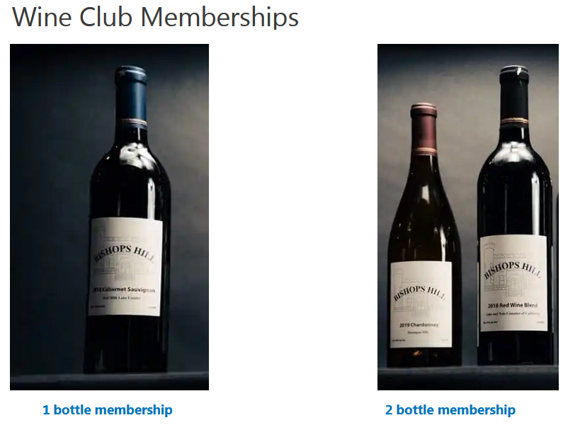
If you have a membership, in order to get your member discounts on wine bottle purchases and wine tastings you have to login under Member Login. After you login you will be at My Account. You can select Subscriptions and see the wine club membership details and your next payment date. You will be charged every month on the day you become a wine club member. You will be billed immediately when joining wine club then every month after. You can cancel membership at any time by hitting cancel below. Change payment is changing your payment method like change to different credit card for example. You can select orders to the left below and see a history of all you’re your purchases.
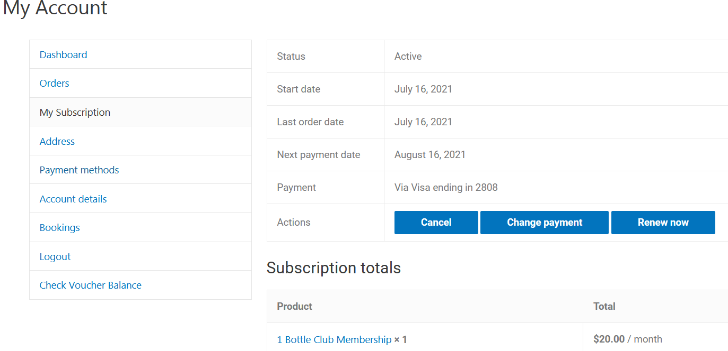
Wine tastings will be 30% off for as many tastings you want with any number of guests that are open for the time slot you are requesting. The membership discount for the wine tasting is activated by applying coupon code TASTE. Wine Class 101 will be 10% off with coupon code CLASS. Neither code is case sensitive so taste and class will work also. See below for wine tasting example.
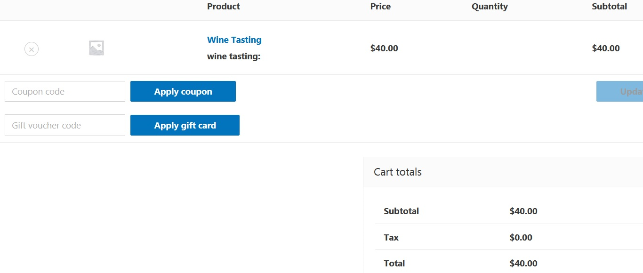
Where it says coupon code enter taste then click on apply coupon. You will see on next page the results.
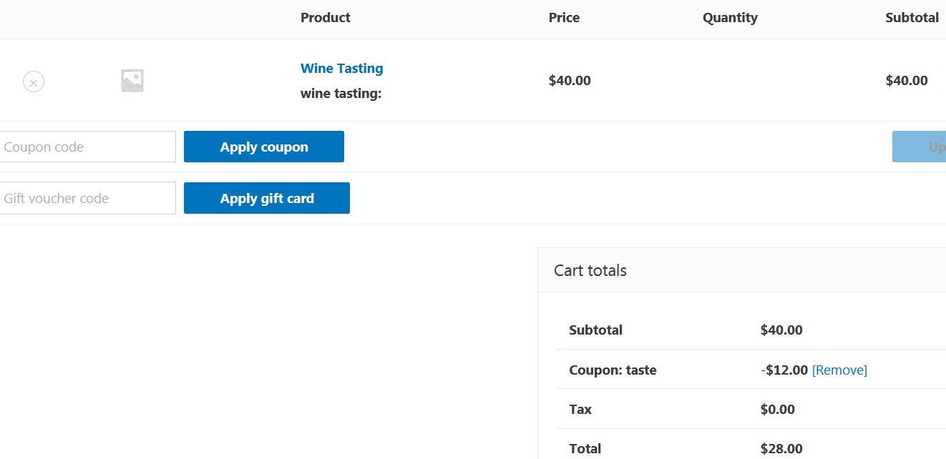
You can see the Coupon: taste reduced the price by 30% under Cart Totals. I want to show an example of what happens if you have a wine tasting and buy a bottle of wine from the shop. The shop is explained on next page.
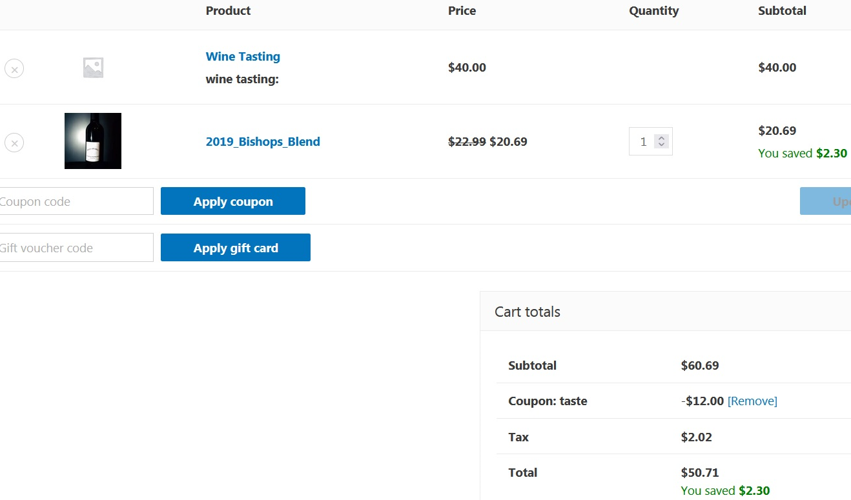
The example above shows the wine tasting for 2 people reduced by 30% in Cart Totals. The coupon only applies to the wine tasting. The 10% off the bottle is under terms of wine club. The tax is only applied to the bottle purchase and not the wine tasting as it should. In this example you saved $14.30.
On the Wine Club drop down you will see the shop option. Select shop and you will see the page below. You will select Wine Club Only so you can receive all the member benefits. If you are not allowed into the store that means you didn’t log into your account.

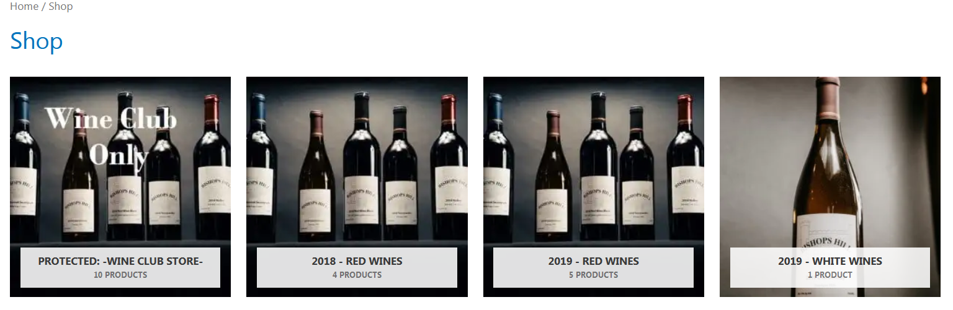

I just want to show you example of what the member-store looks like when purchasing wine.

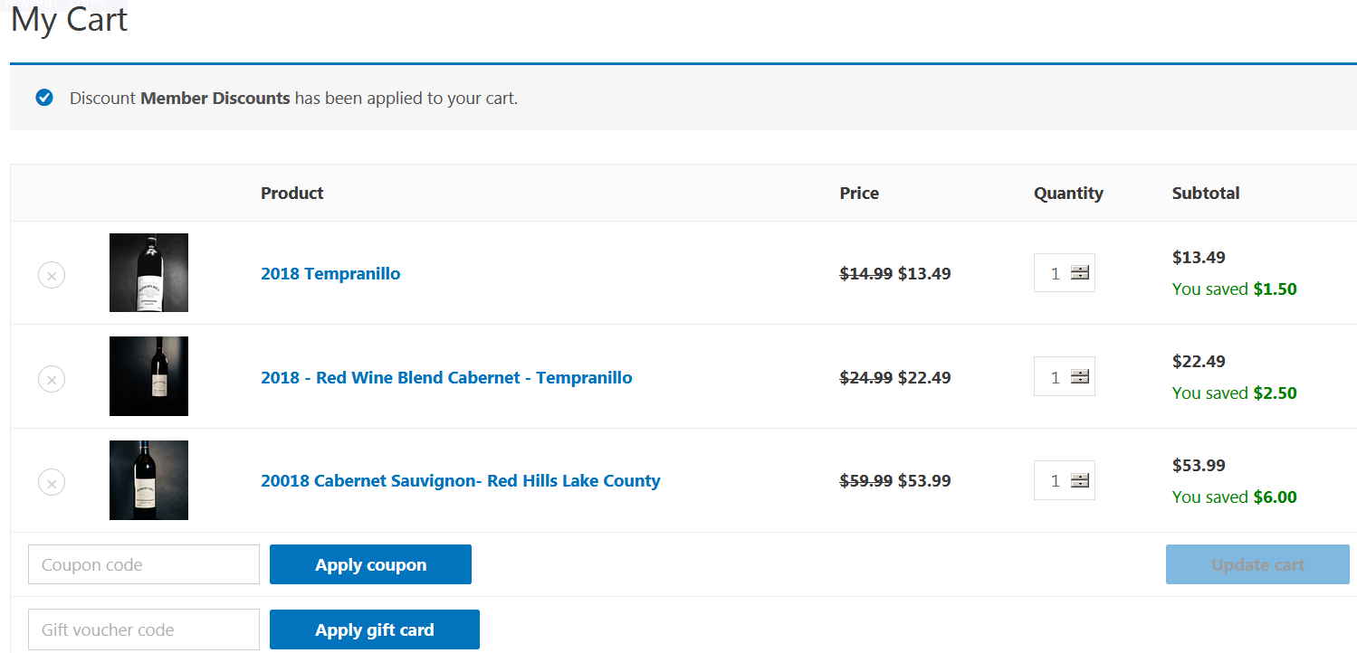

As you can see I have 3 bottles selected and have a 10% discount on each. Since I need to purchase 6 bottles to get 15% off I will update the Tempranillo to 4. See below what happens.
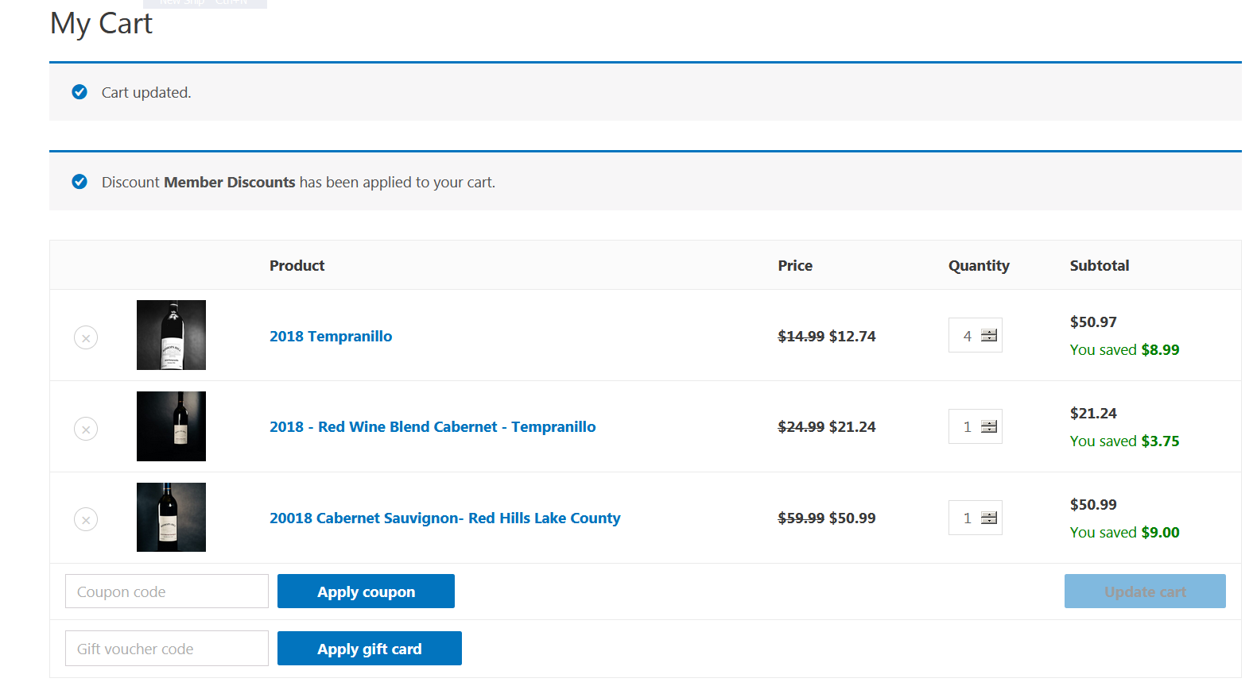
It’s easiest to see the 2019 Cabernet. It went from $6 discount to $9, which is now 15% off because I hit the 6 bottle threshold. I will now update Tempranillo to 10 bottles and you will see the cab go from $9 to $12 discount.
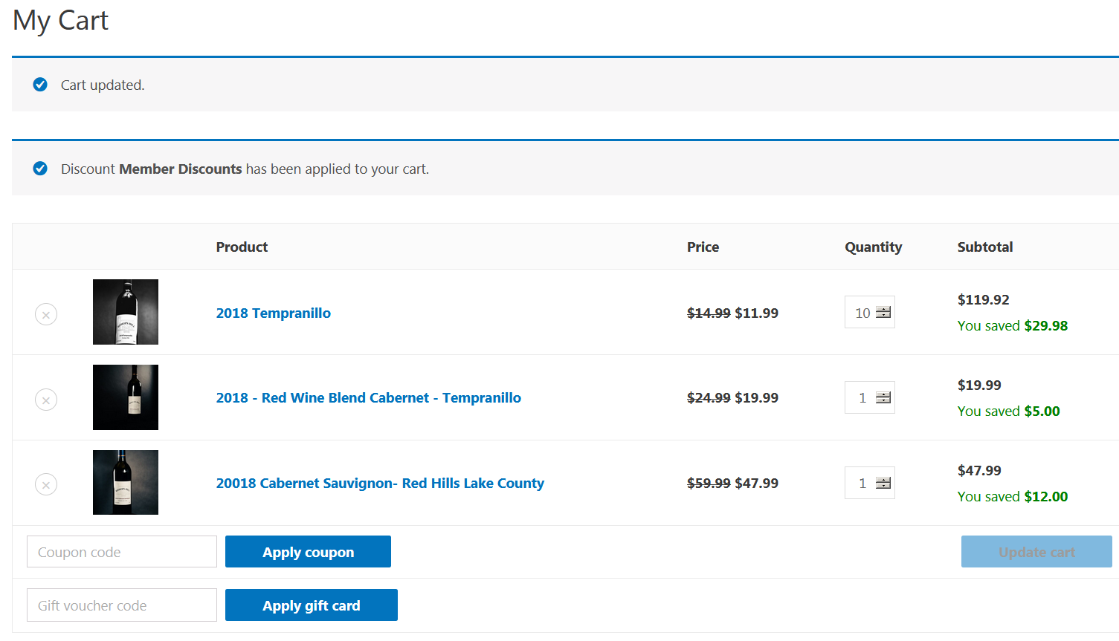

I hope this explains everything clearly. However, if you have any issues or questions don’t hesitate to call Frank at 773-269-7365. Thank you for becoming a member of Bishops Hill wine club.

